CSO Lab 6: Getting to Know the 8051 MCU
Question: -- Write a program that uses a push button to start and stop a 4-bit binary up counter.
--Display the 4-bit binary up counter using the LED.
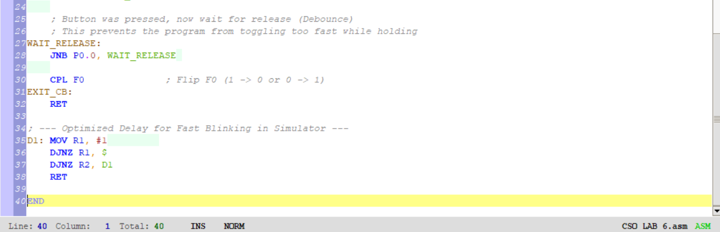
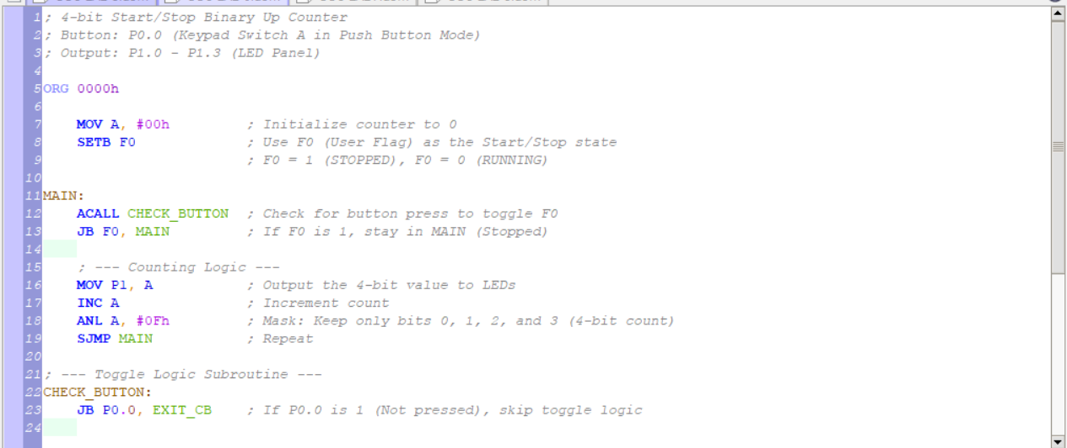

Demo Video
https://drive.google.com/drive/folders/1rnfQfxfr03Xsfzd2DmIeLebdBVp3SIGy

